**Task on Linux:**

1. Create user with name Techie and provide sudo access to user.

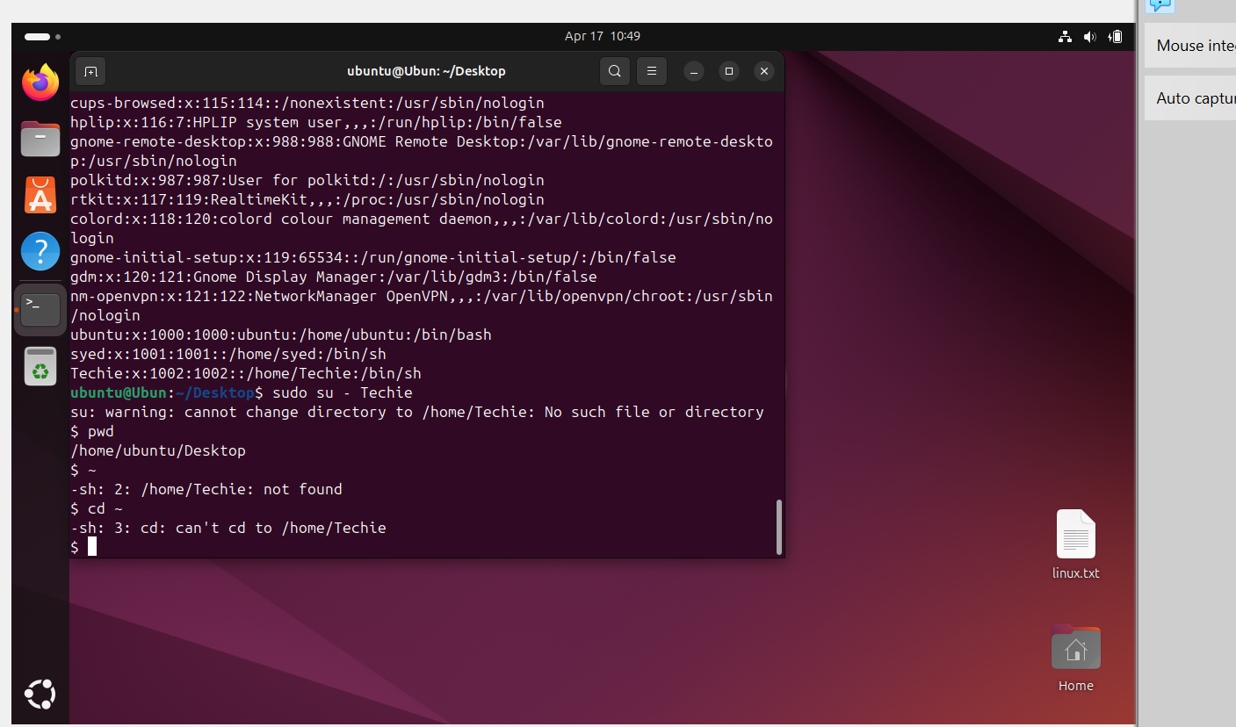

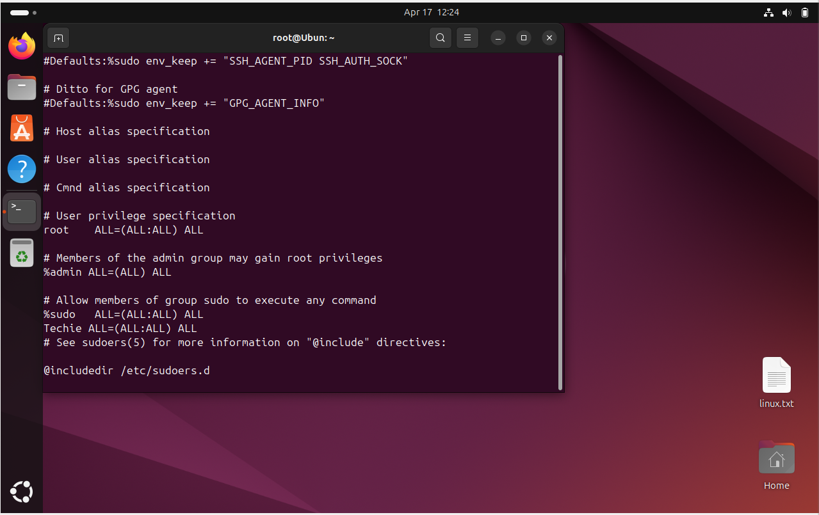

1. Navigate to the home Directory

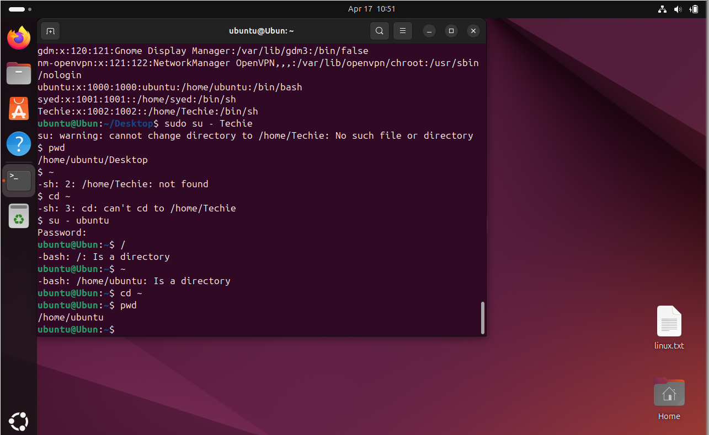

1. Create a new directory

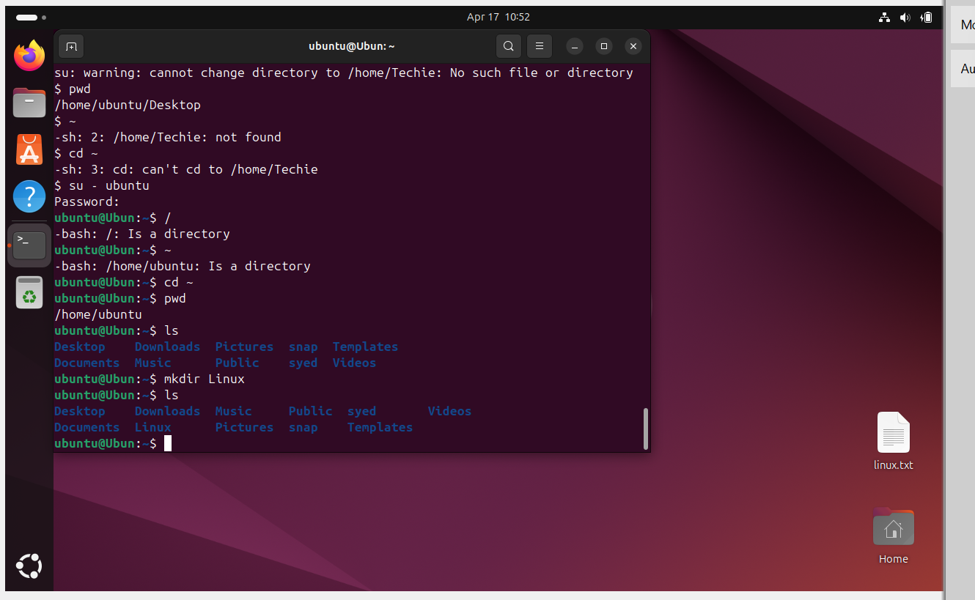

1. List of the contents of a directory

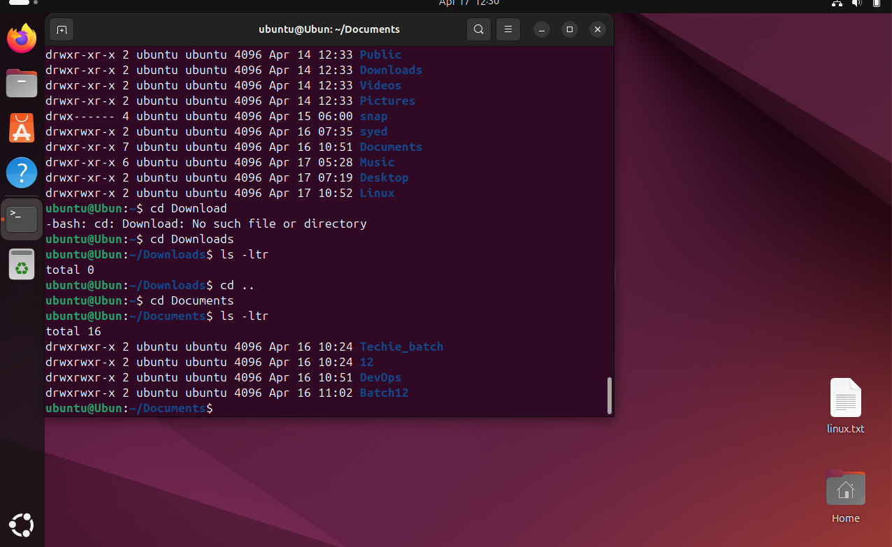

5.Change the current directory

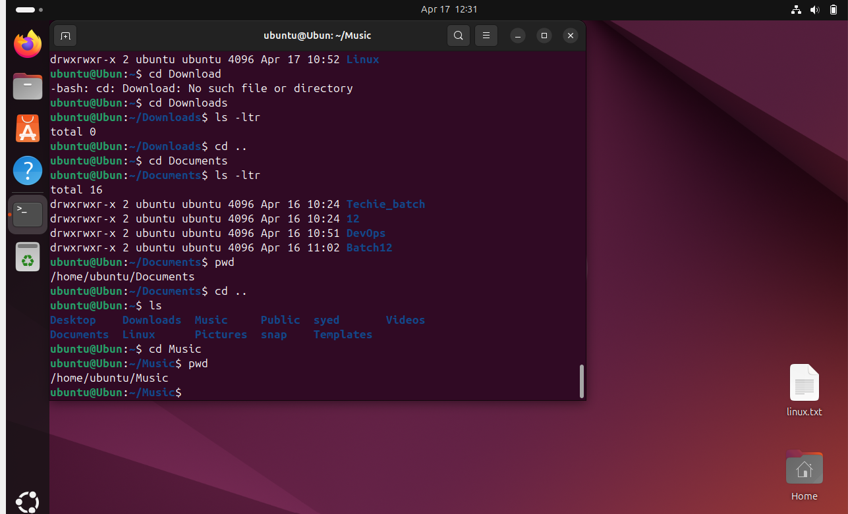

6. Create a new empty file

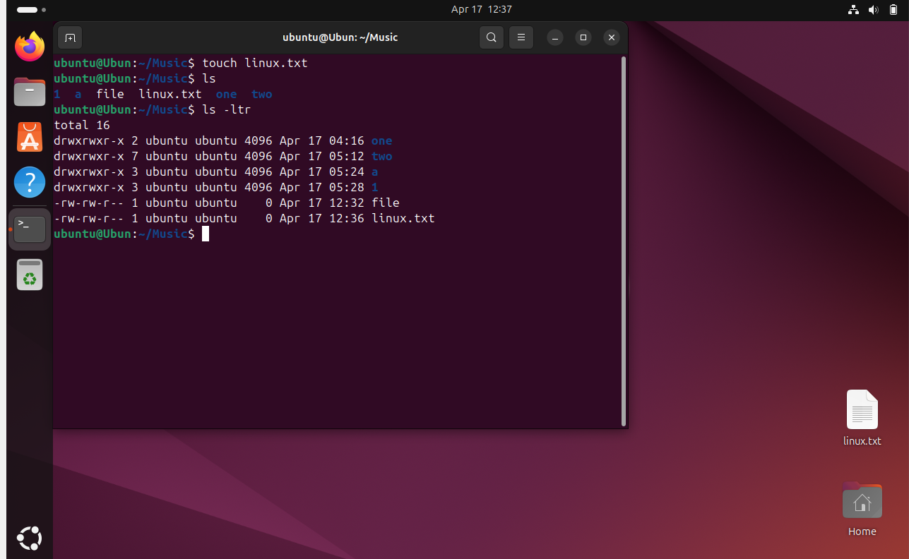

7. View of the contents of the file

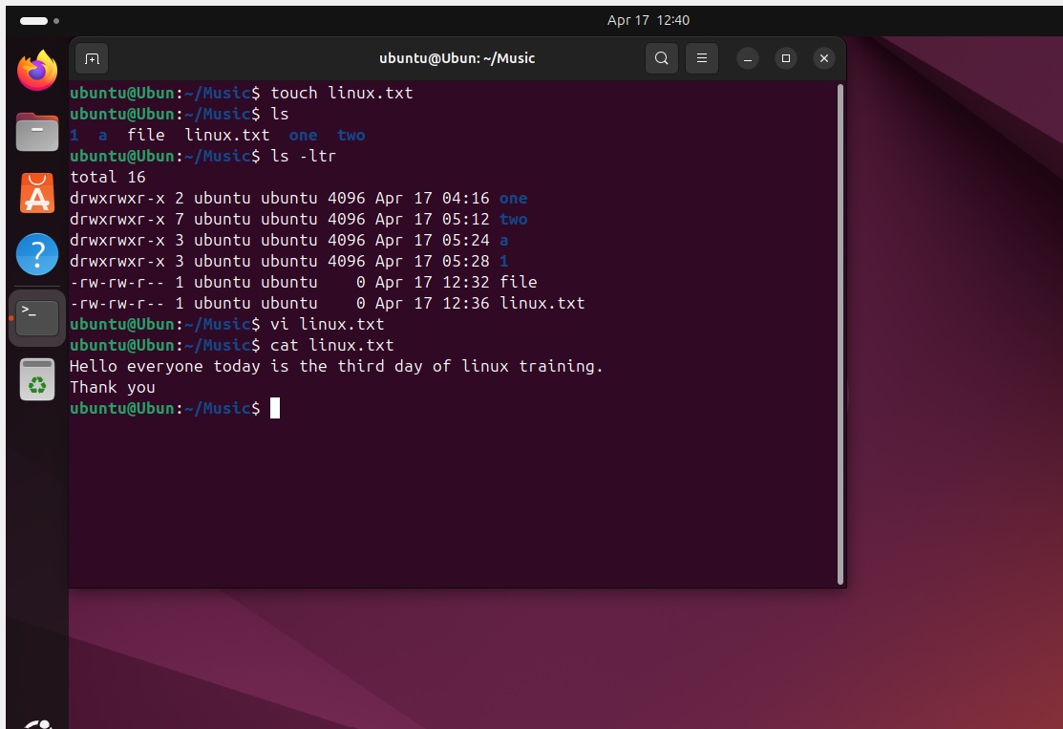

8. copy file to another location

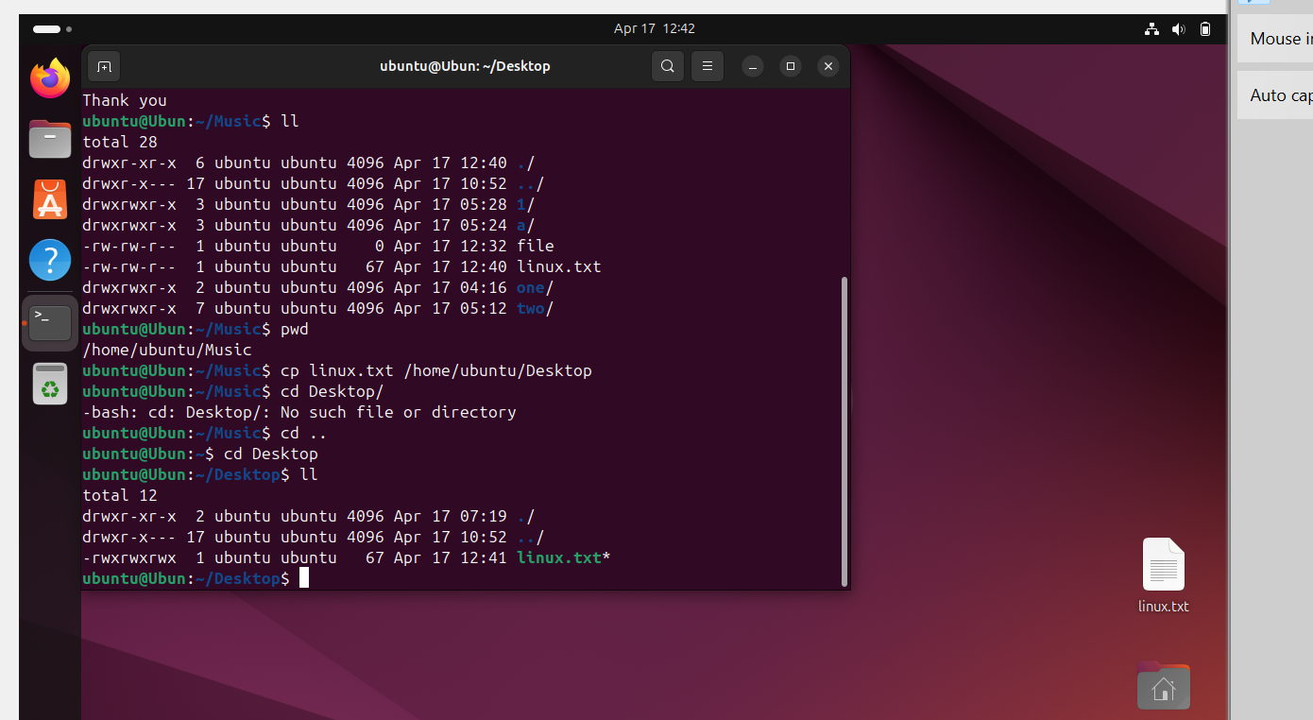

9. Move file to another location

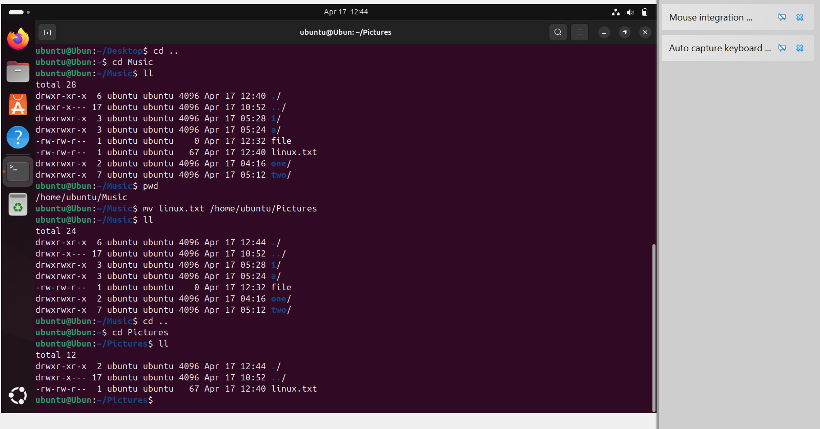

10. Rename a file

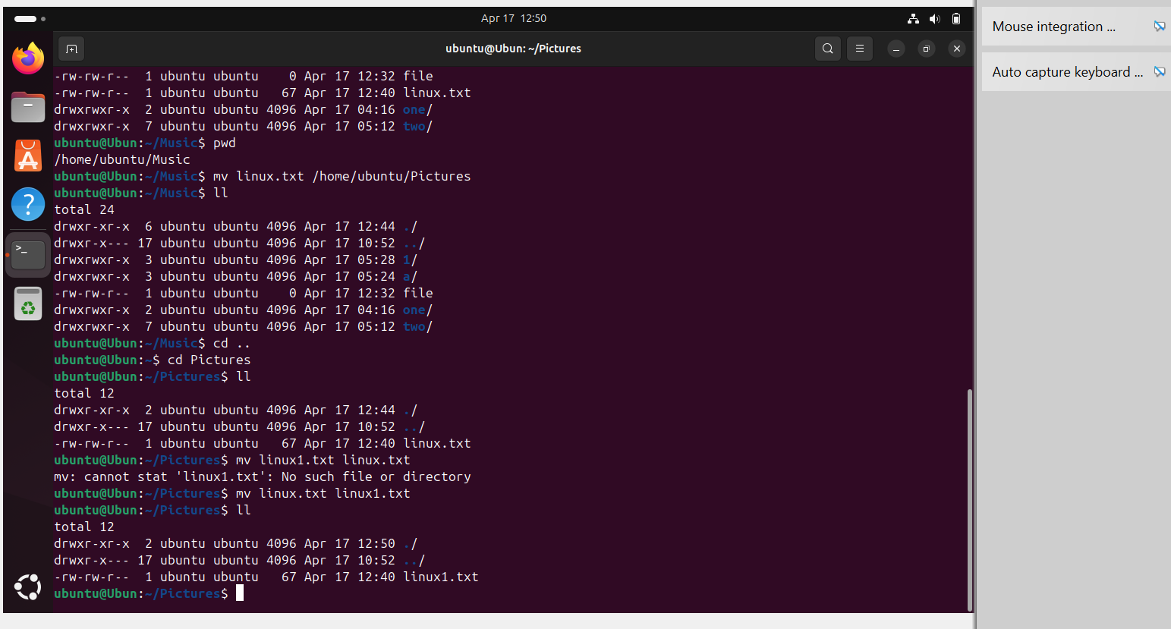

11. Delete a file

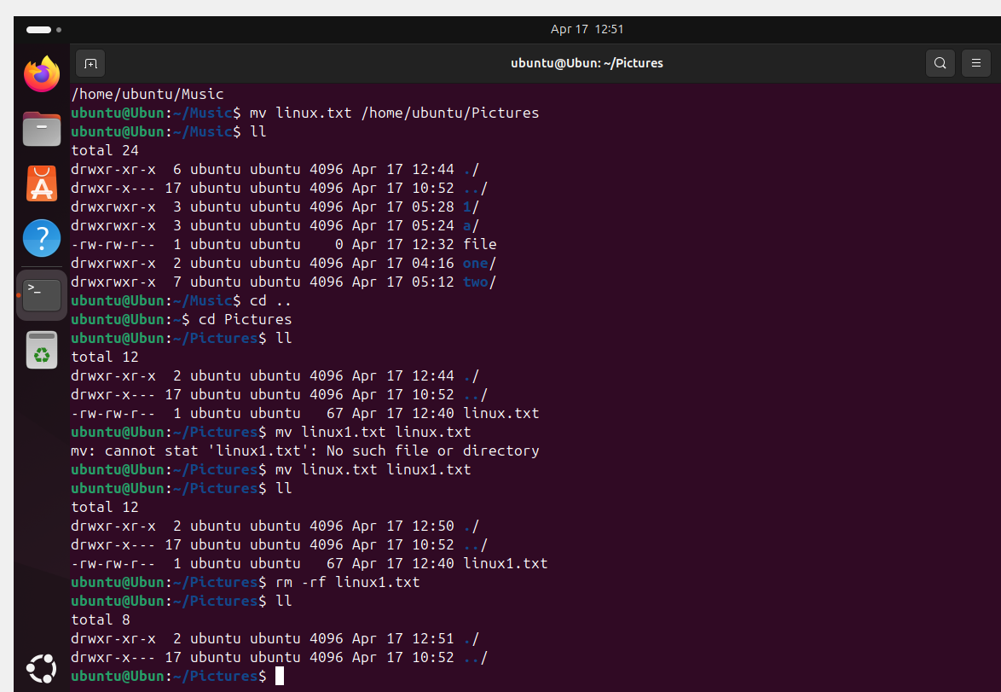

12. Grant or revoke permissions on a file or a directory

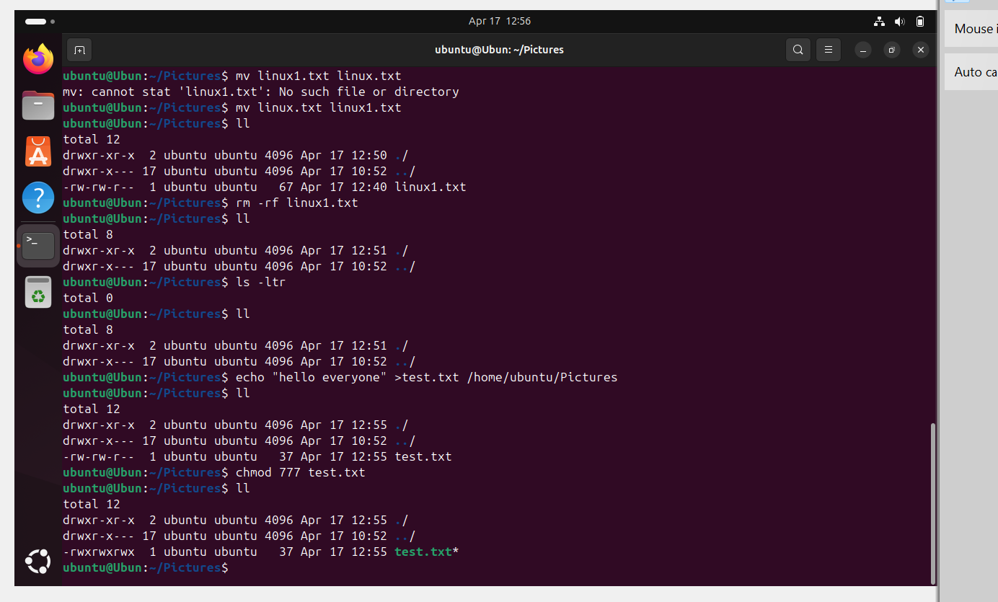

13. To view the current date and time

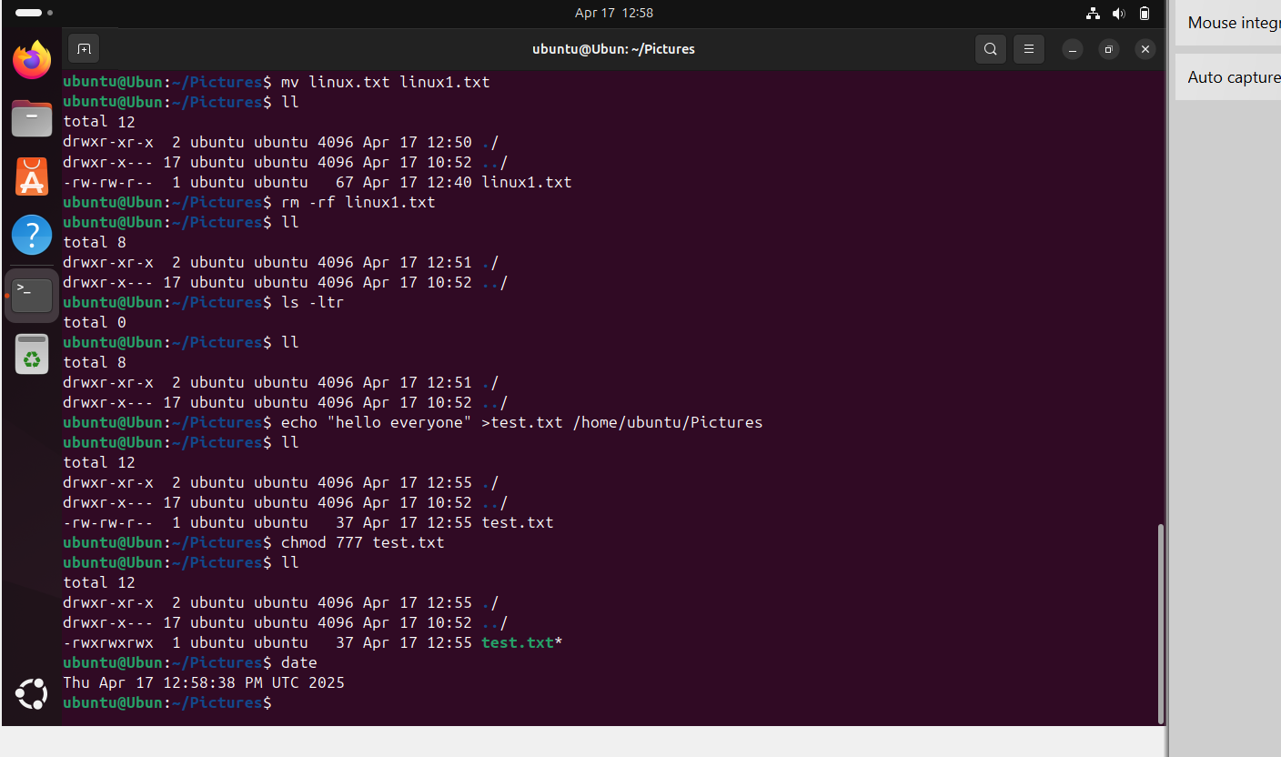

14. Check the system uptime

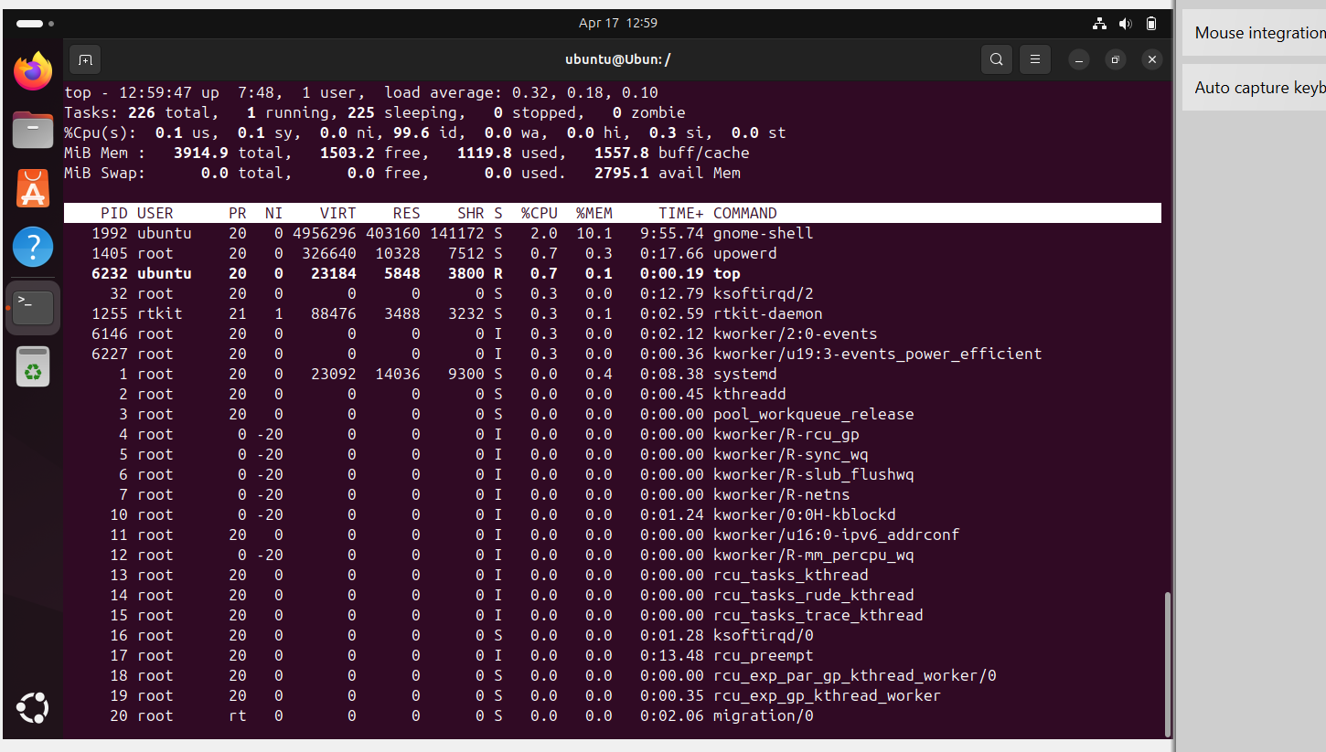

15. View the running process

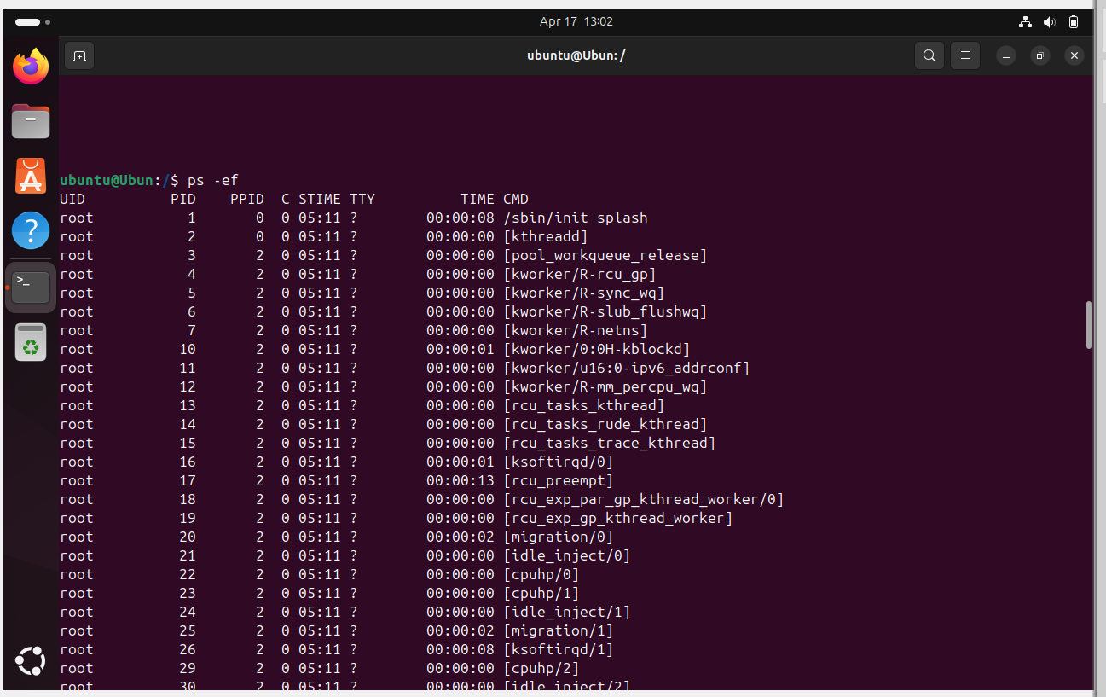

16. Kill a running process

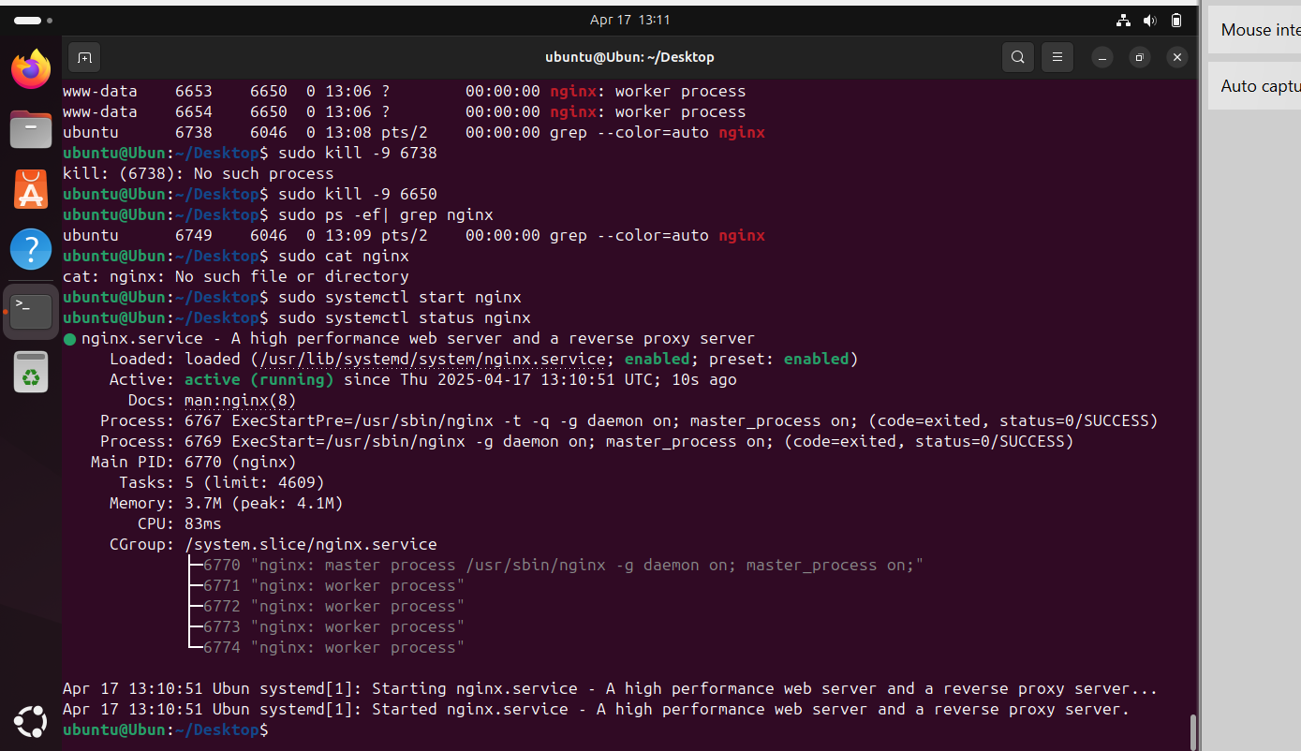

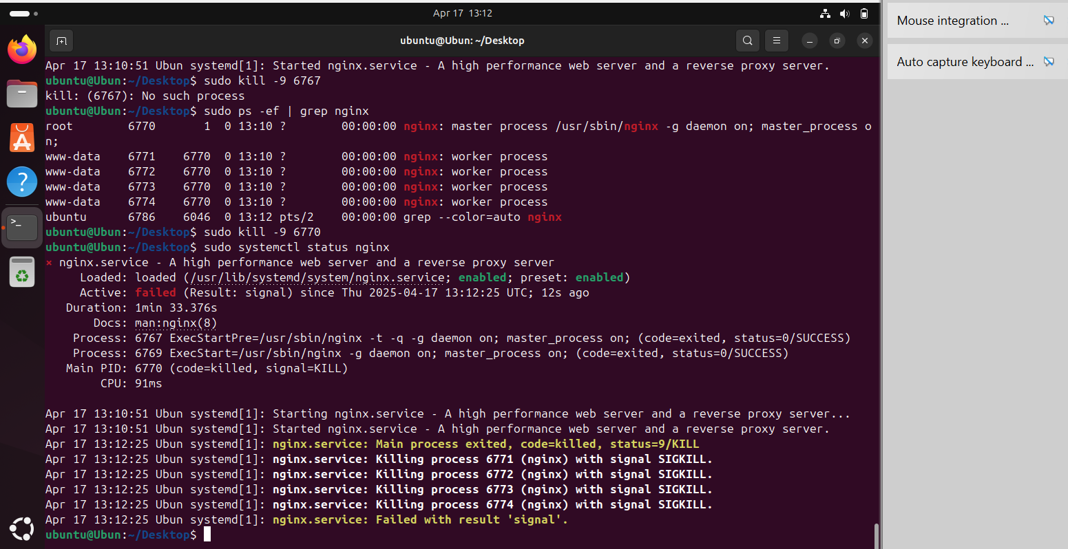

17. Install a package using the package manager

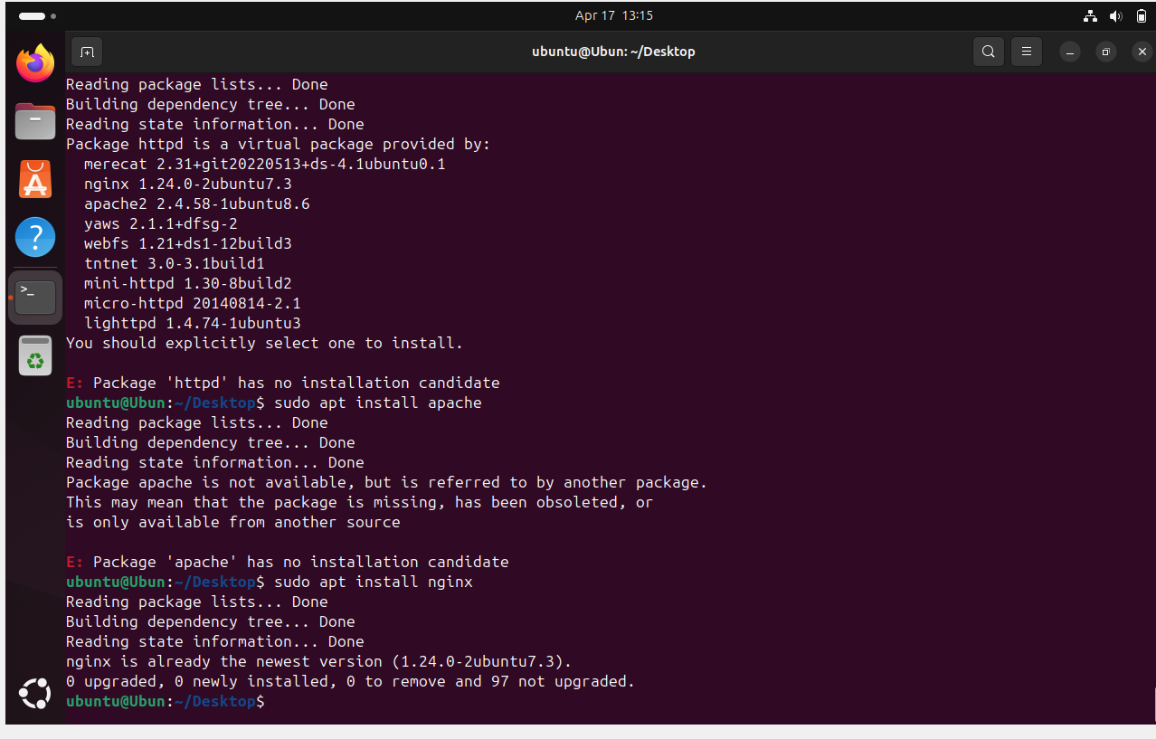

18. Update the system packages

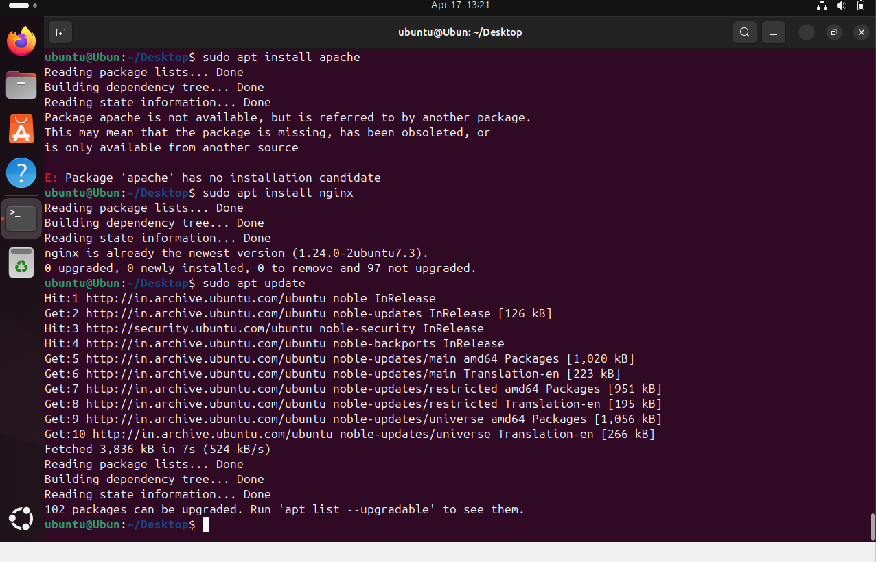

19. Create a symbolic link

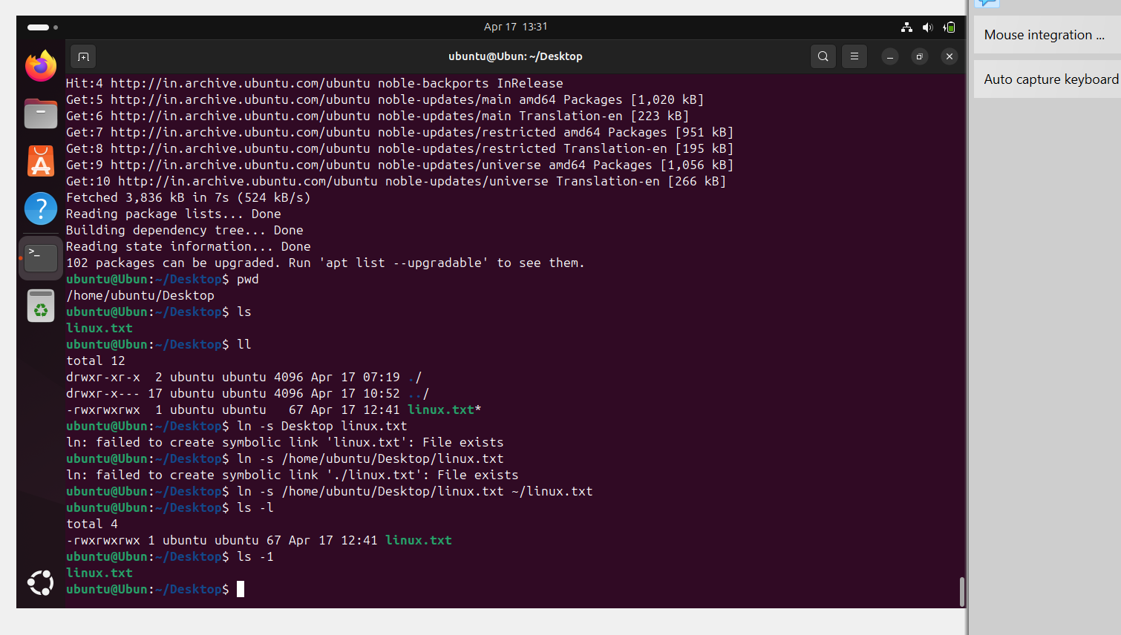

20. Search for files using the find command

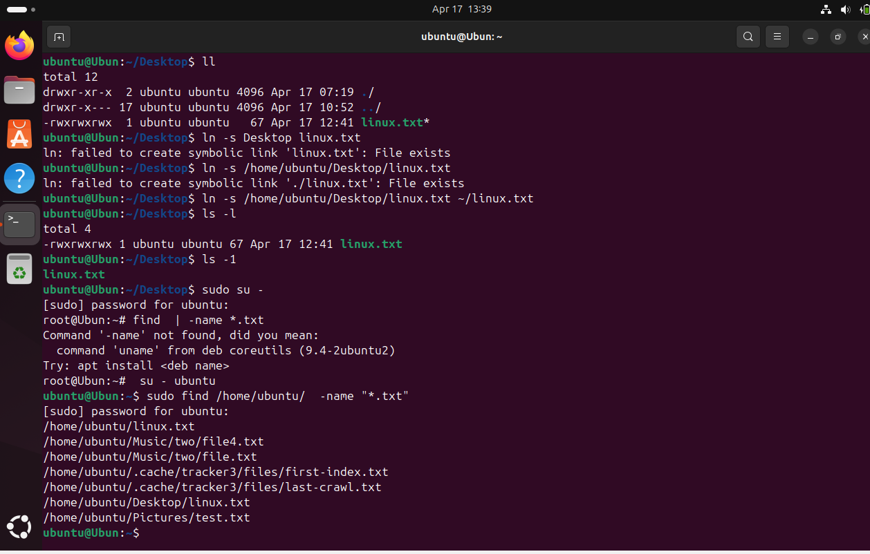

21.Compress and decompress the files using tar

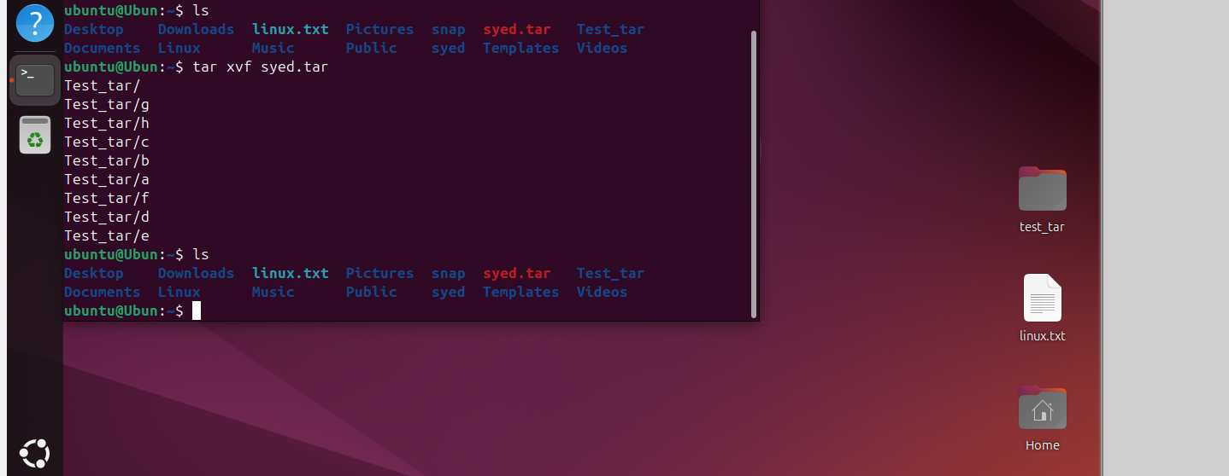22. Monitor system resource s with top or htop

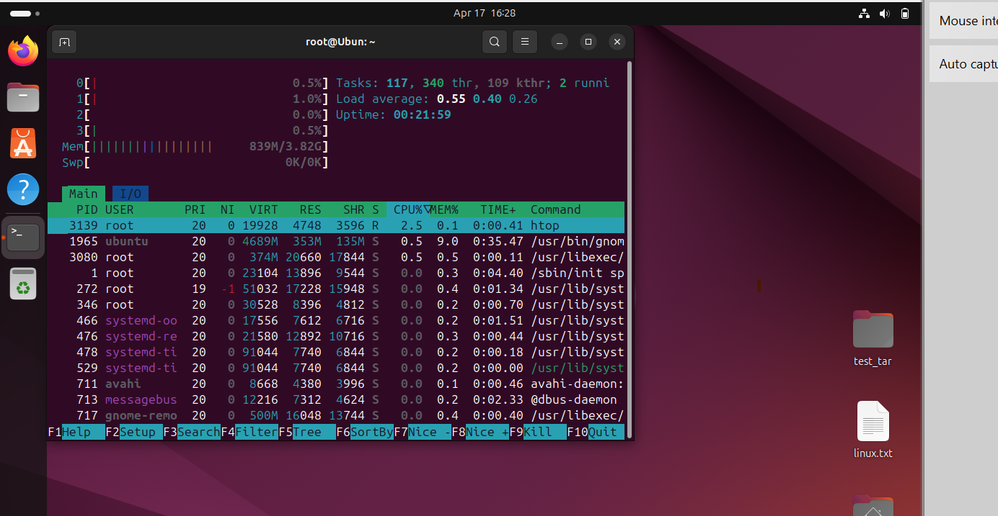23. Create and manage user groups

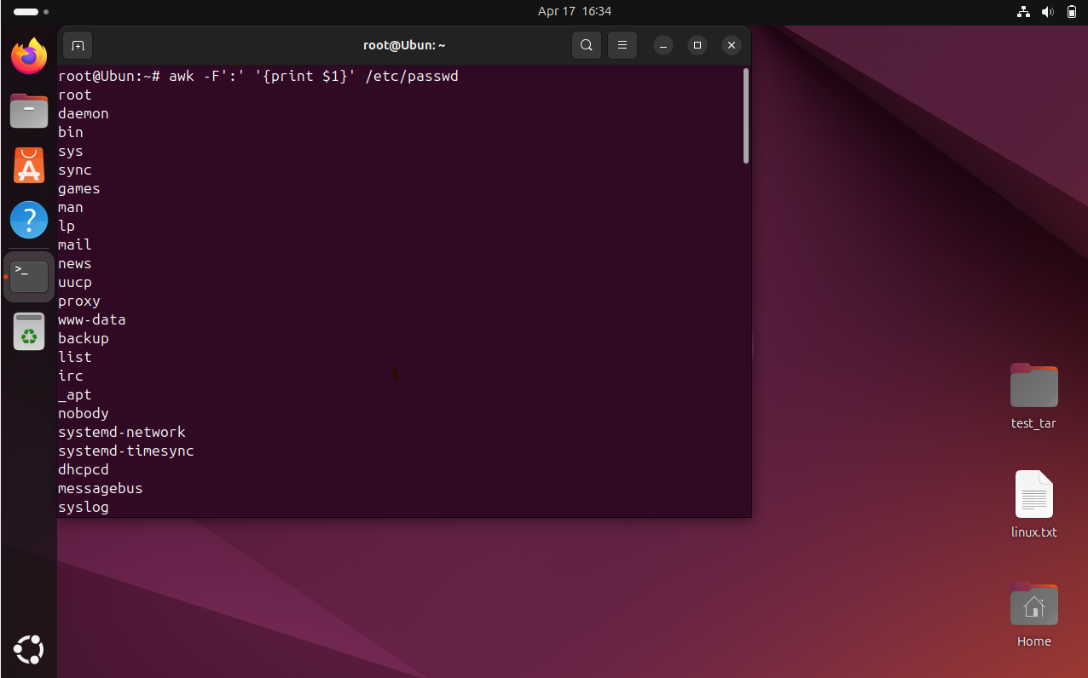

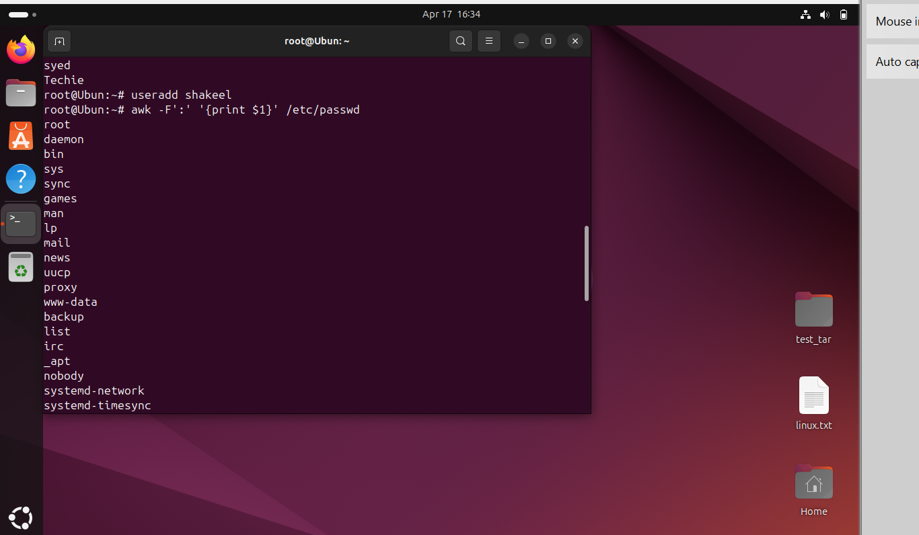

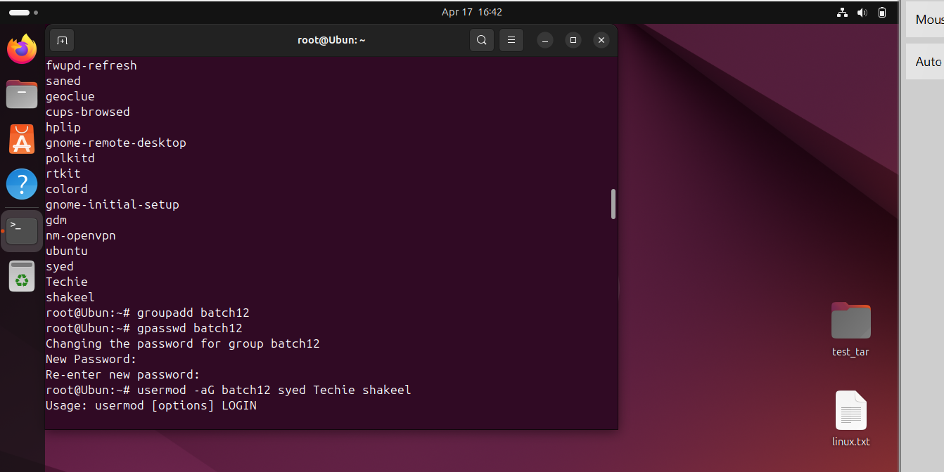

24. Set up SSH password less authentication.

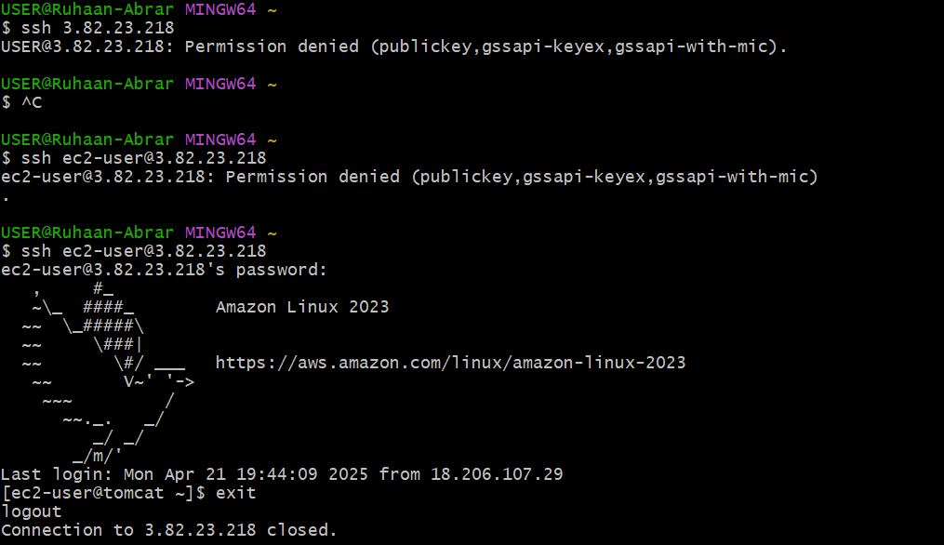

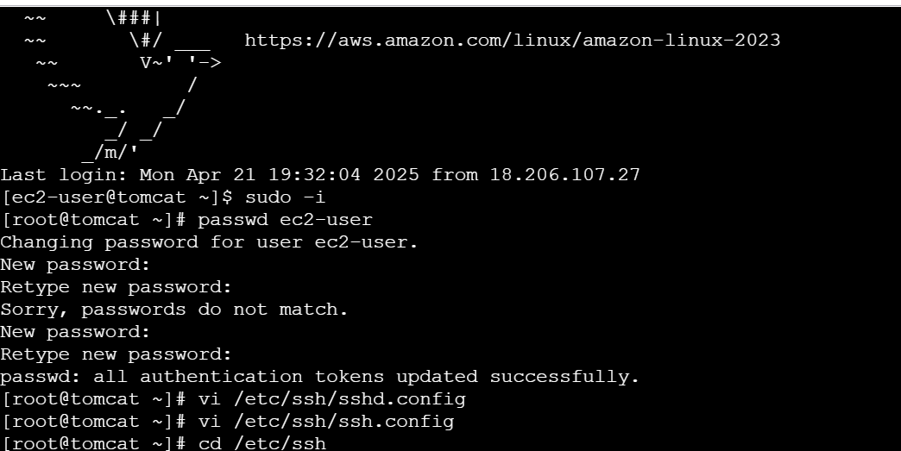

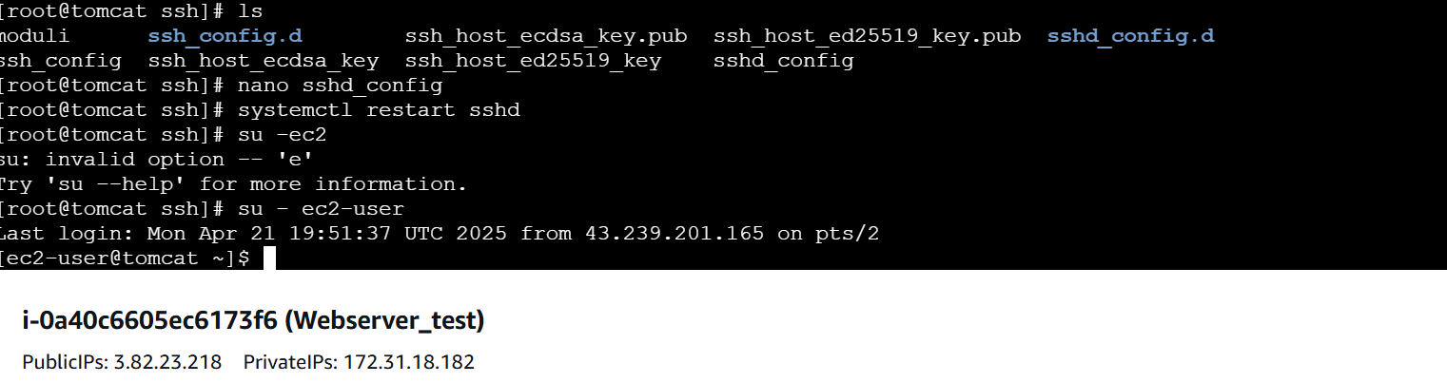

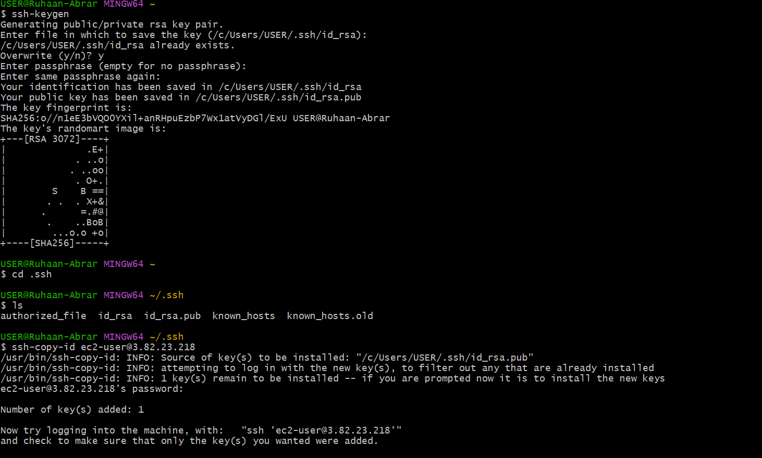

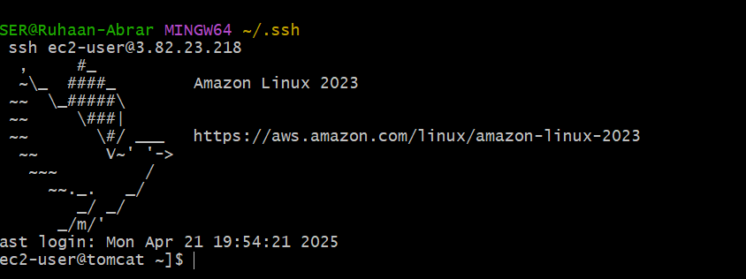

25. Monitor log files using tail or grep

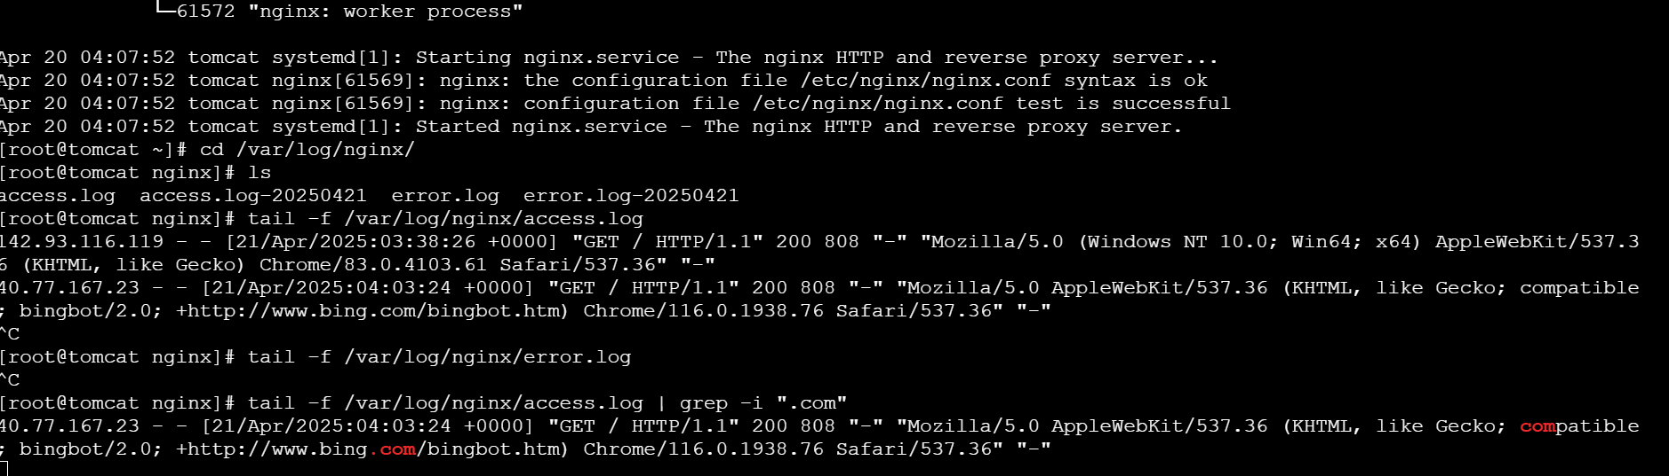

26. Set up a web server (e.g., Apache or Nginx).

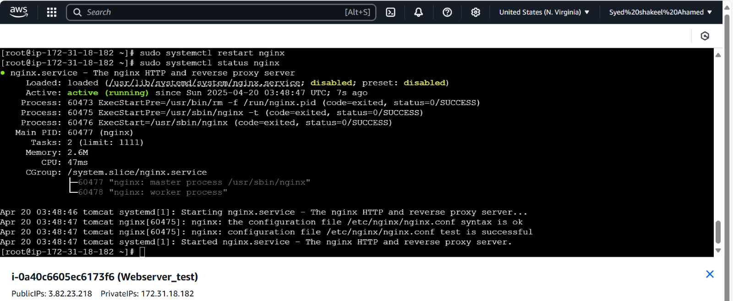

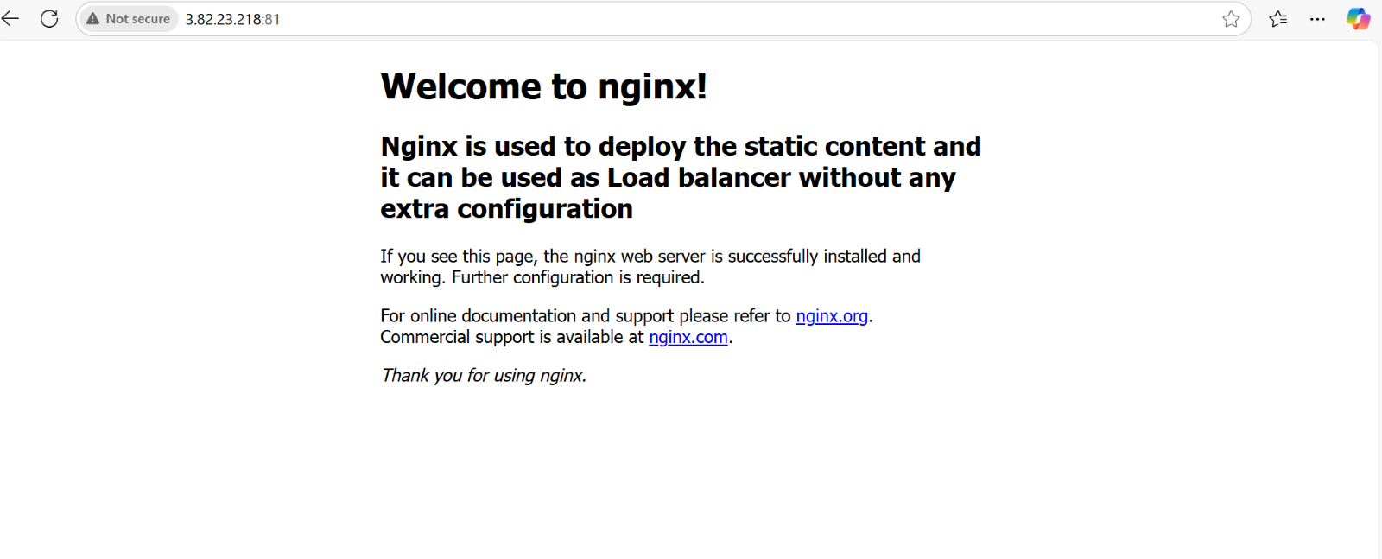

1. Configure and secure a MySQL Database.

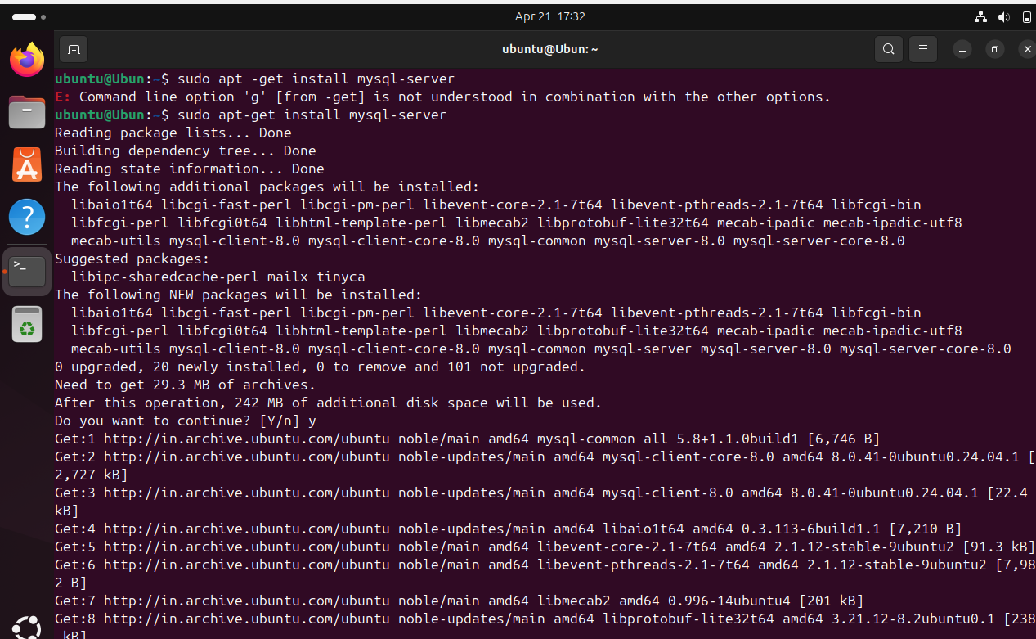

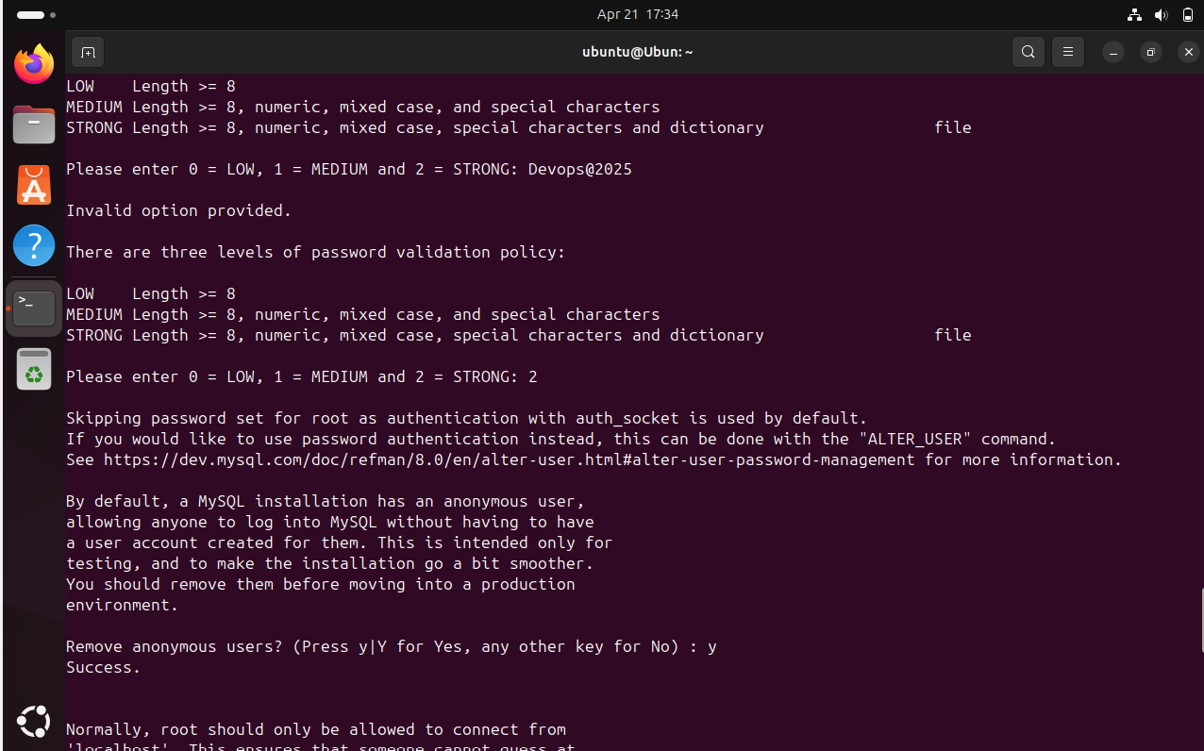

1. 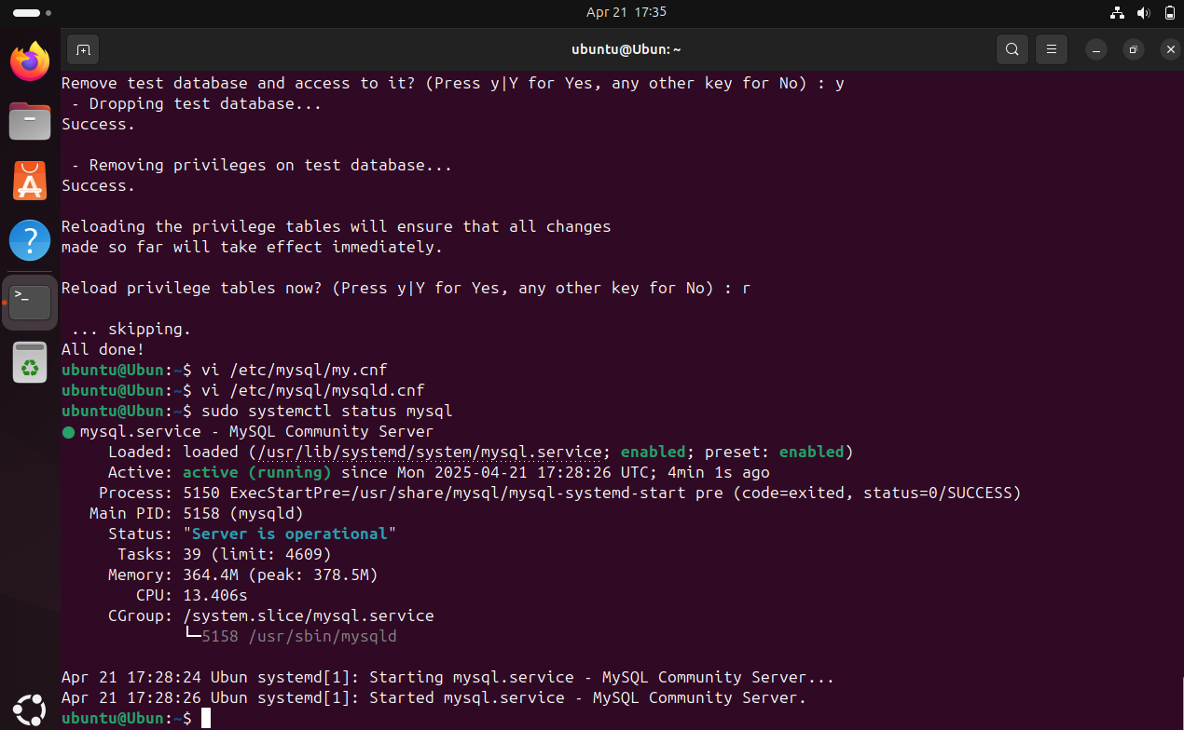

28.Set up a Application Server (e.g.,Apache Tomcat)

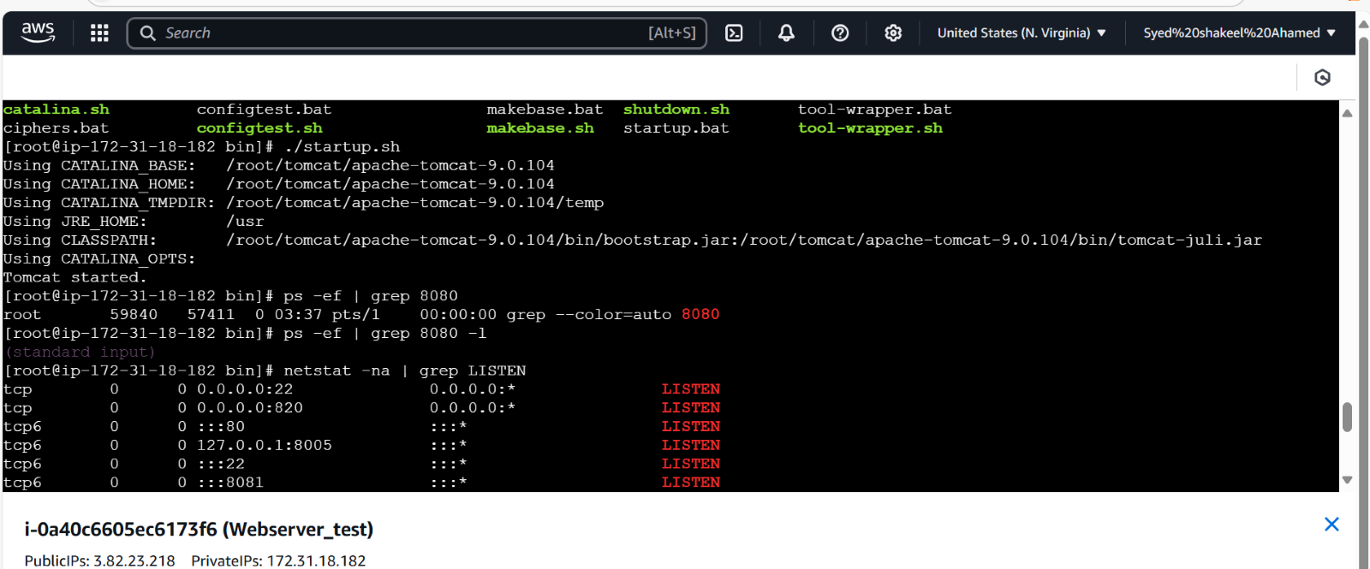  
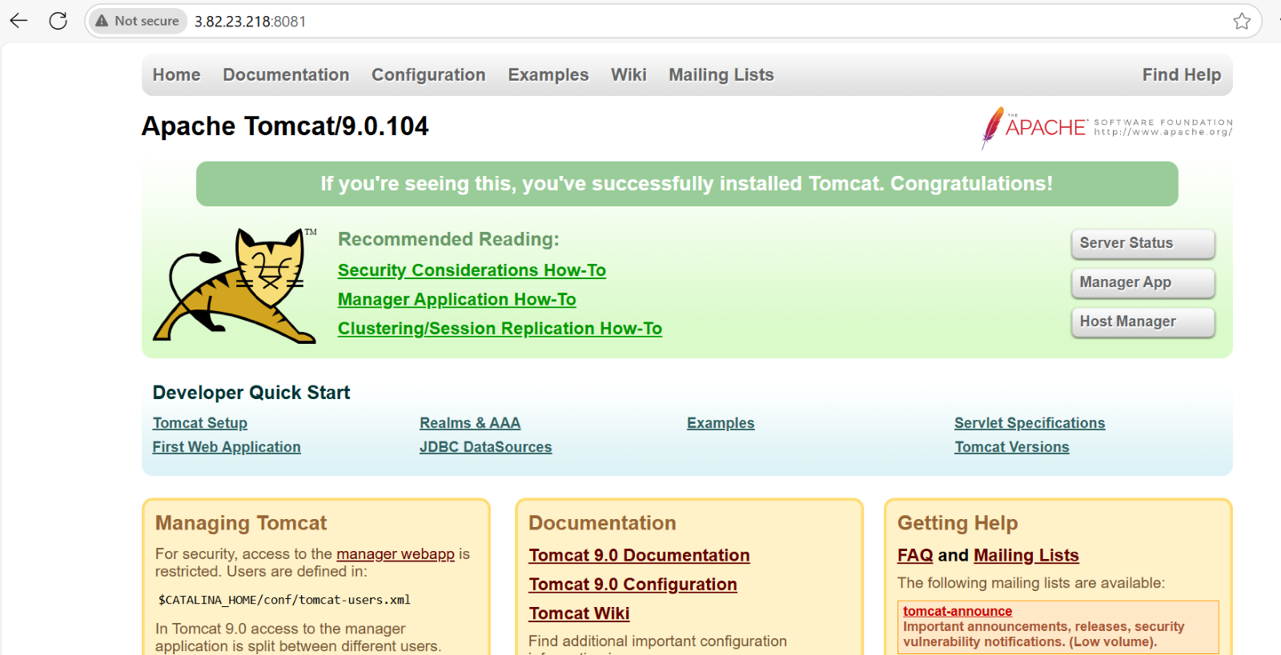

1. create a service file for Apache Tomcat.(Should execute by using systemtctl command)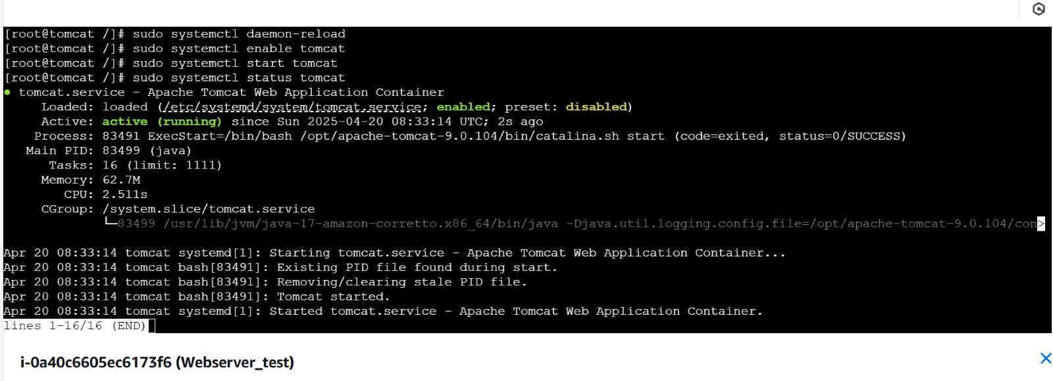

30. Print specific columns from a delimited file

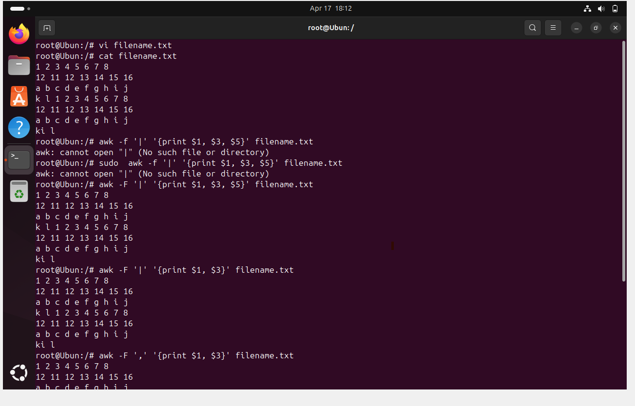

31. Filter and print lines based on the specific pattern or condition.

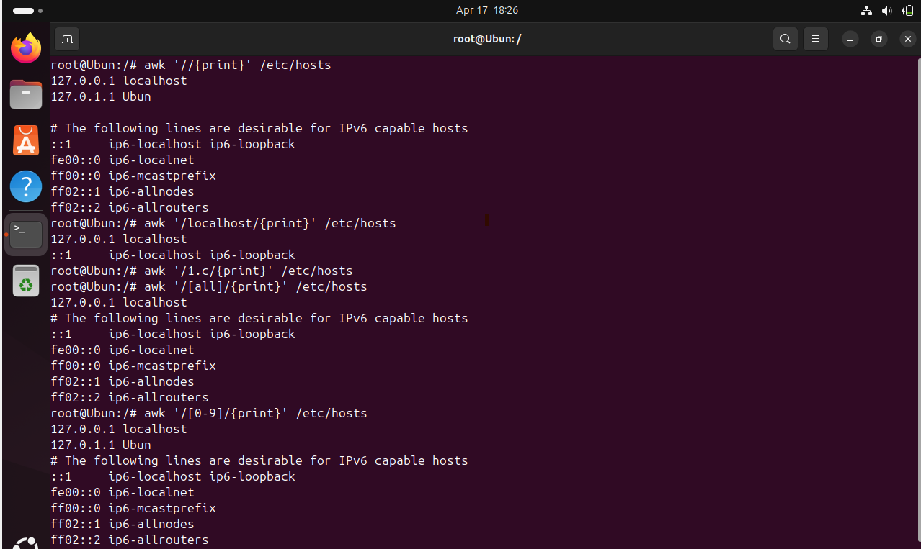

32. Calculate and print the average, sum, or other statistics of a column.

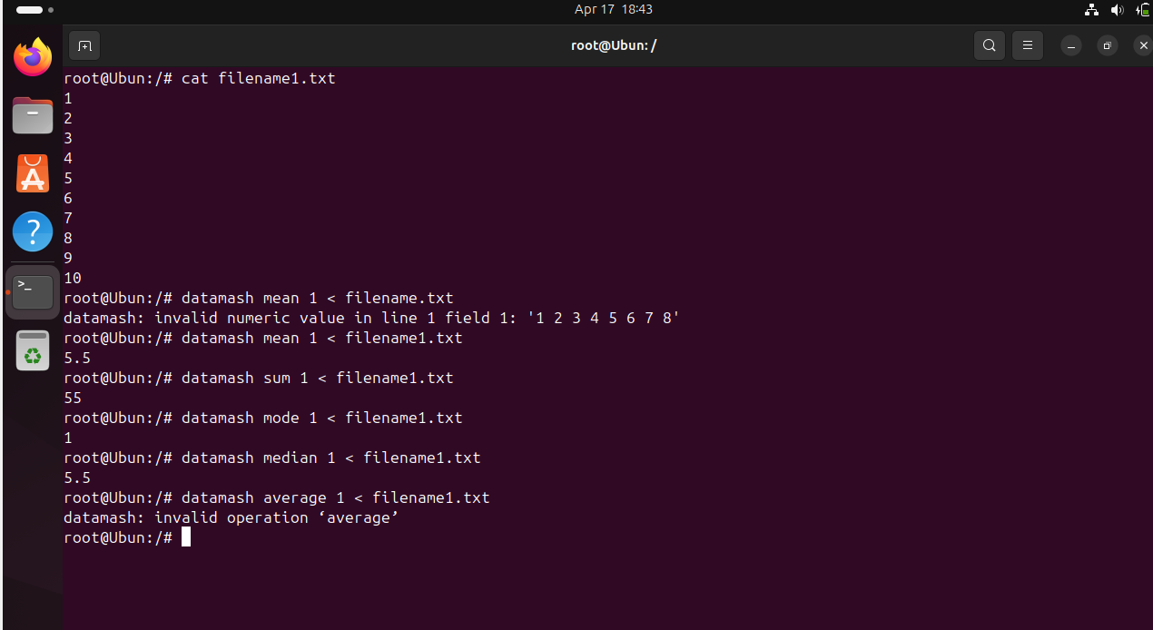

33. Perform string manipulation, such as extracting substrings or changing case. 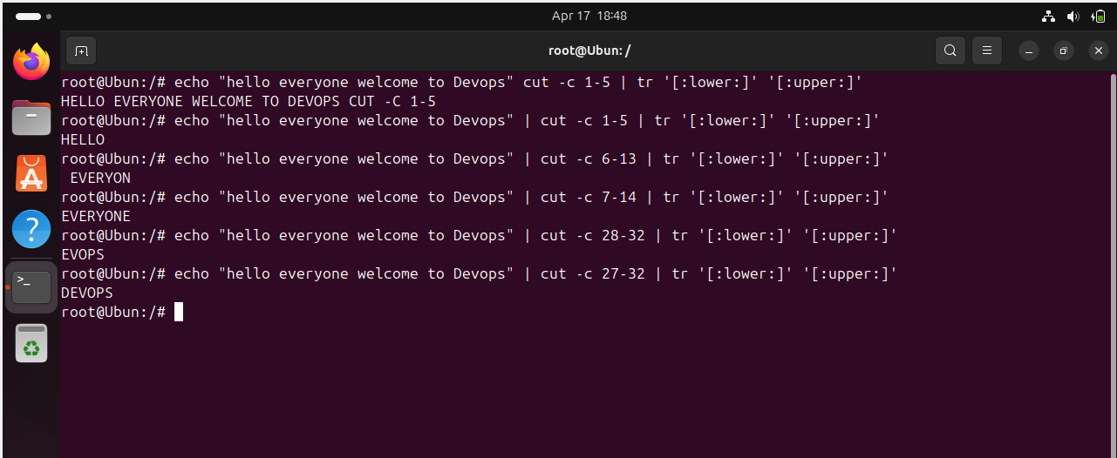

34. Count the occurrences of a specific pattern in a file.

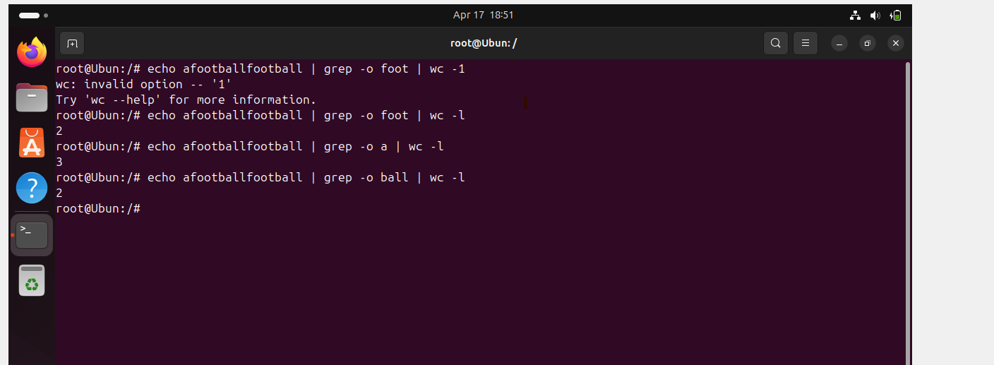

35. Sort lines based on a specific field or column.

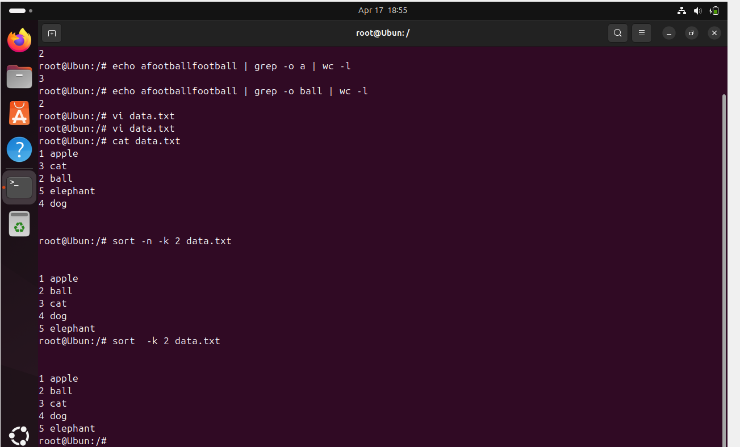

36. Merge multiple files based on a common field or column.

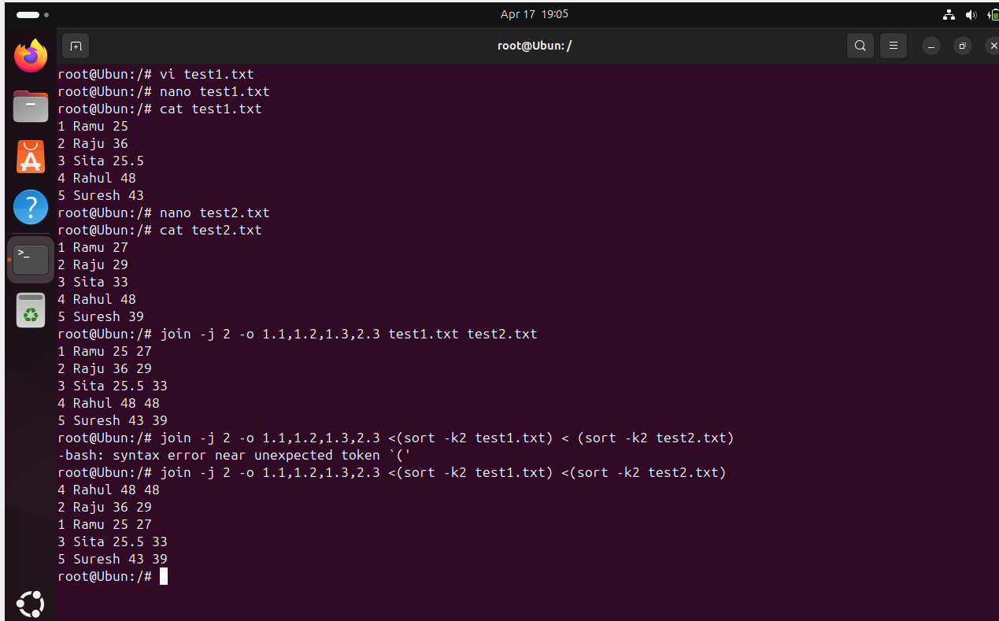

37. Substitute text in a file using search and replace.

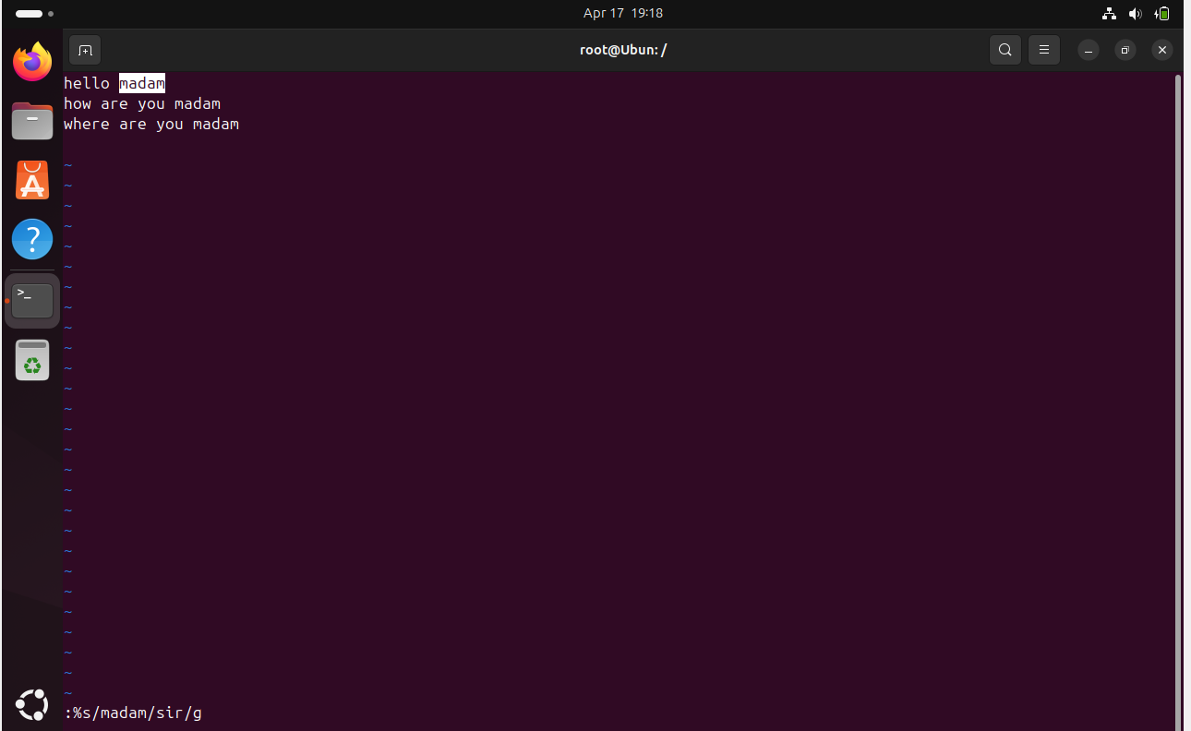

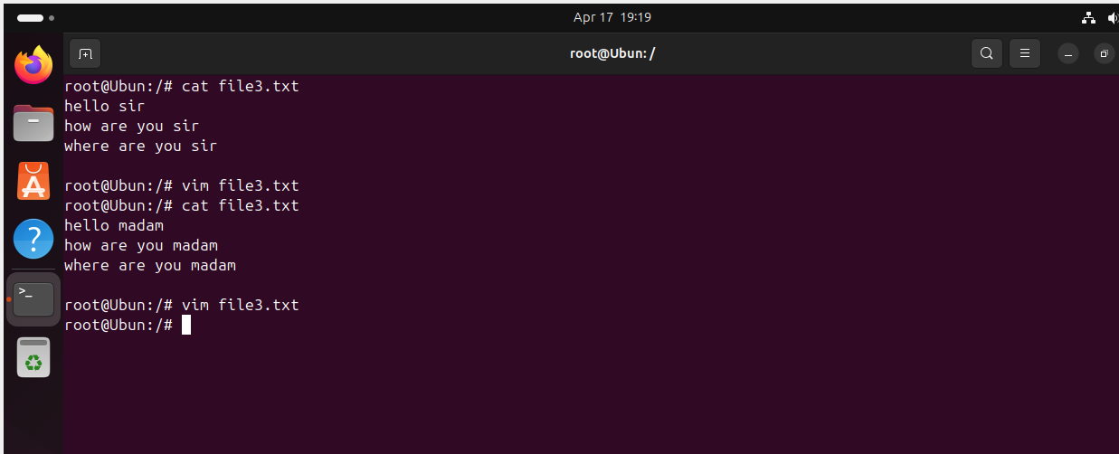

38. Delete specific lines based on a pattern or line number.

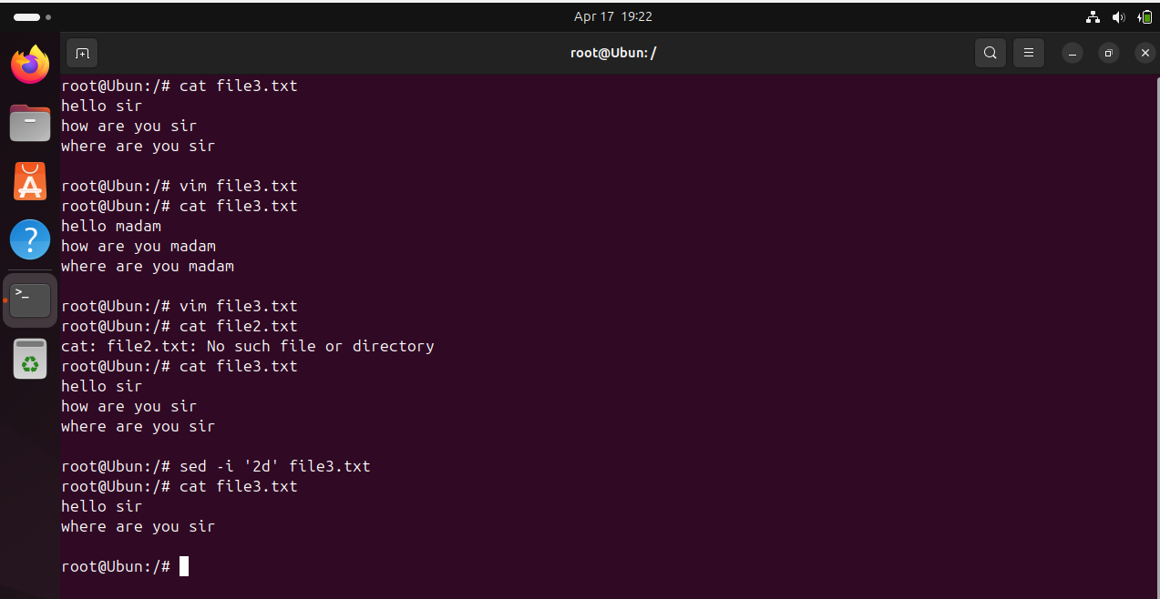

39. Append or insert text before or after a specific pattern or line.

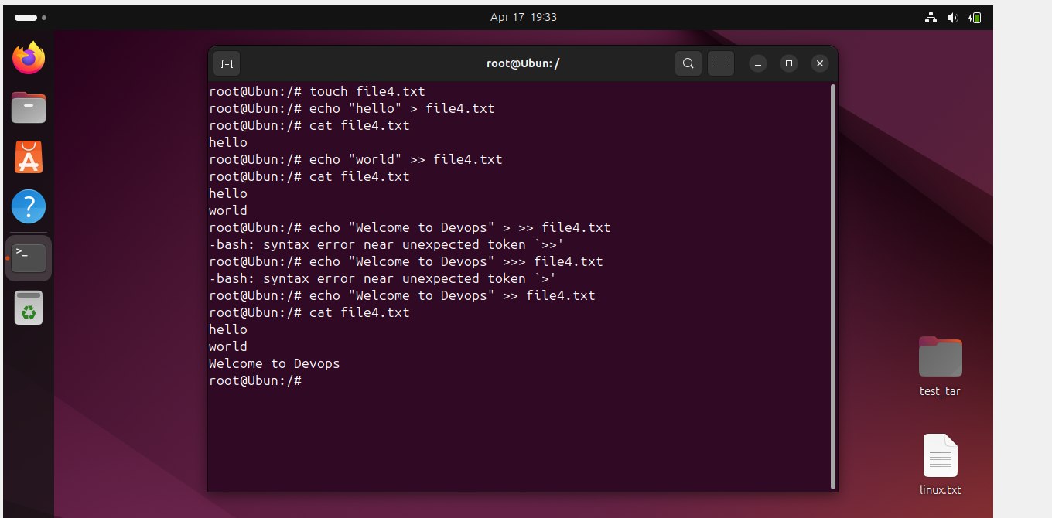

40. Print only specific lines from a file.

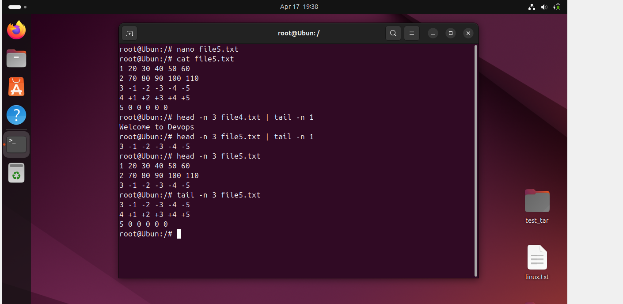

41. Copy file from linux to windows machine

42. 5 use cases for AWK and 5 use cases for sed

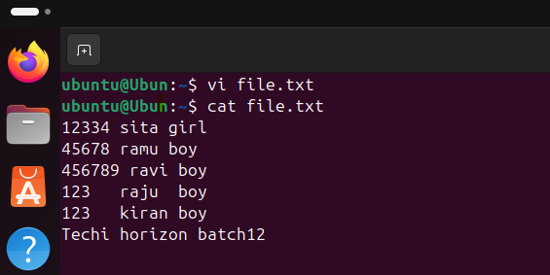

AWK use cases

1. Data Extraction: Extract specific columns or fields from a text file or output

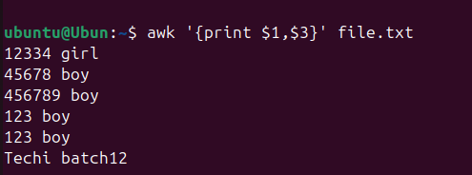

2. Data Filtering: Filter rows based on conditions

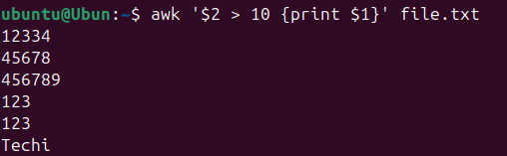

3. Text processing: Perform Calculations or string manipulations



4. Log analysis: Analyze log files to extract specific information

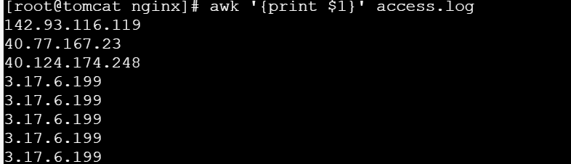

5.Report Generation: Generate formatted reports from data.

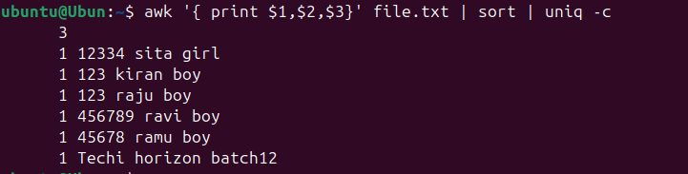

Sed Use cases:

1.Text Replacement: Replace specific text patterns

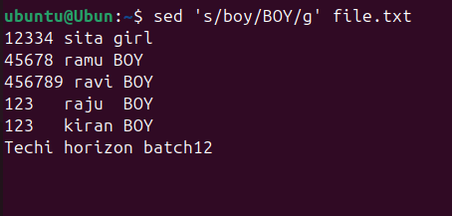

2.Line deletion: Delete specific lines based on patterns

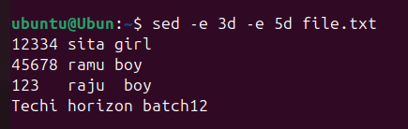

3. Line insertion: Insert text at specific lines

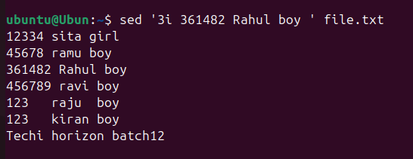

4. Text formatting: Format text, such as converting tabs to spaces.

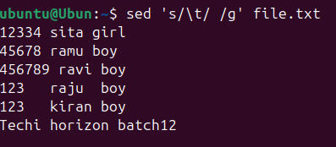

5. Stream Editing: Edit output from pipes

